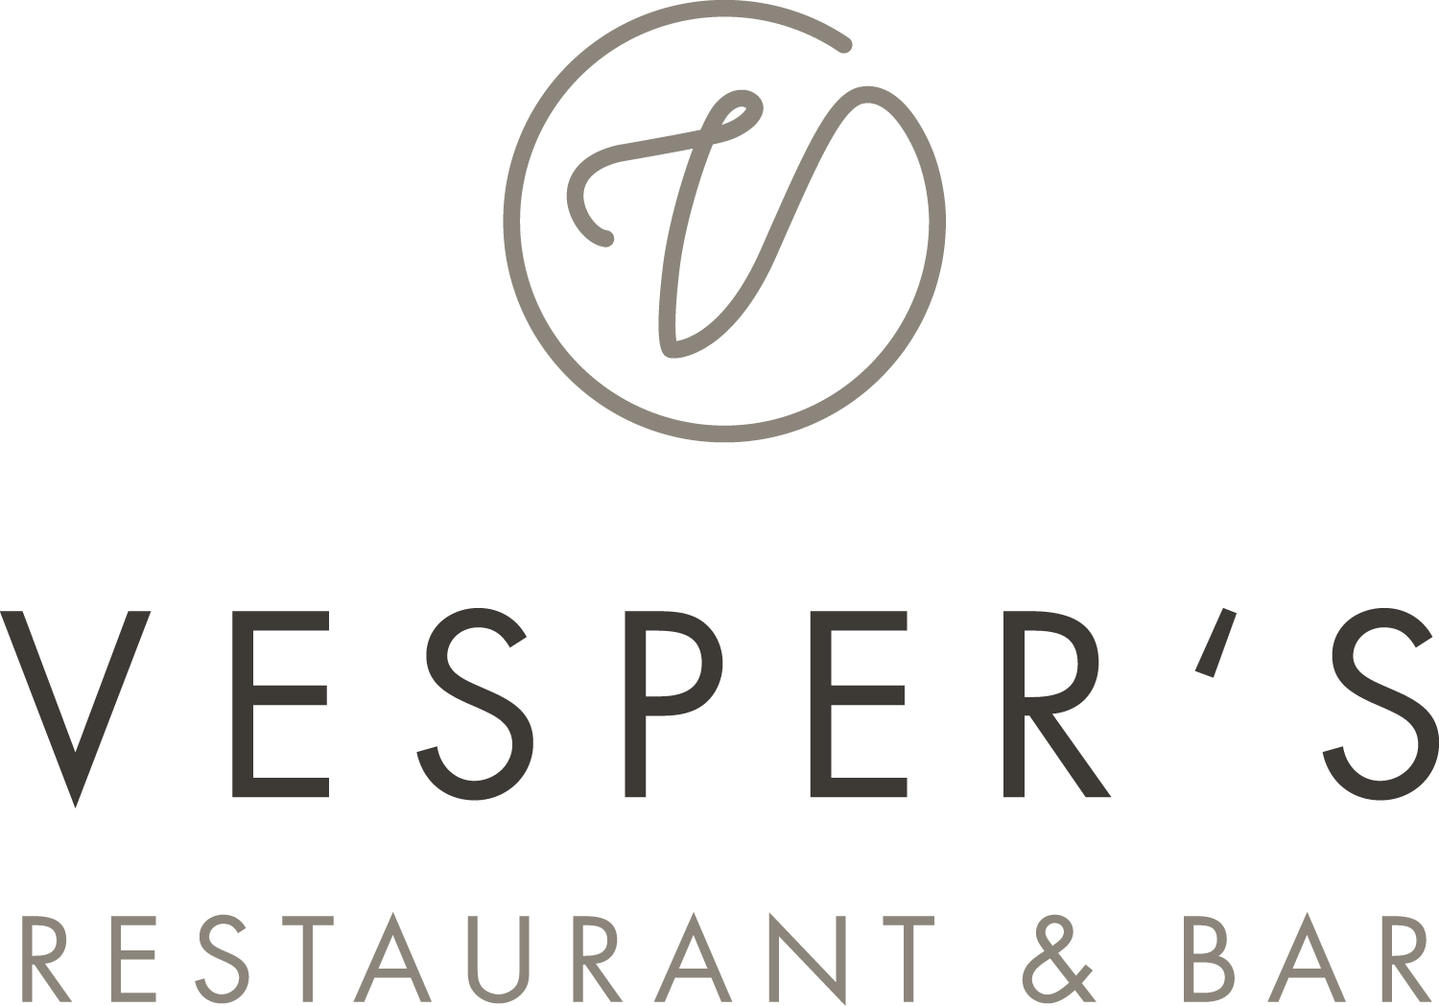

Menueboard
Monday till Saturday 12pm – 05pm | Sunday 12 till 9pm

Cream of chanterelle soup thyme pastry -v- 12
Bacon pancake salad 18,5
„Nürnberger Rostbratwürstchen“ Sauerkraut | mashed potatos 18,5
Pinsa tuna | tomato | red onion | mozzarella 16,5
Beef carpaccio aragula| Parmesan 16,5
Homemade pasta Gorgonzola | Spinach | Tomato 15
Seasonal salad vinaigrette or yoghurt dressing 13
− beef stripes +7,9
− poulard stripes nature or Asian-style +5,9
Matie “housewife style” | potato 19
Matie fried potatoes | bacon beans 20,5
Vesper’s Currywurst (180gr) homemade curry sauce | fries 17
Rumpsteak (200gr) Steakhouse fries | grilled vegetable | sour cream | jus 33
Wiener Schnitzel fried potatoes bacon & onion | cucumber salad | lemon 29,9
Burger crispy chicken | cucumber sesame salad | wasabi dip | fries 25
Plum compote salted caramel ice-cream 11

V- vegetarian | All prices including service and taxes

